10th Magnitude
The Estée Lauder Companies Inc. - Disaster Recovery
CPM BC/DR Playbook

Document Creation Record
Document Identifier : | 10M-CON-DR
Date: | 09/22/2018

Date | Comment | Author
06/16/2020 | Update CPM DR | Angel Garcia

Document Change Record
Issue | Item | Reason for Change

Document Approvals
Name | Job Title | Date | Comments

Table of Contents
Introduction 5
Purpose 5
Scope 5
Key Concepts 5
Solutions Overview Diagram 6
Replication process 6
Failover process 6
Roles and Responsibilities 8
Declaring a Disaster 9
DR Process 9
Invocation Process (in the case of a Live DR) 9
Critical Incident Management Process 9
Failover Process 10
Close out of the DR 10
Post Incident Report after the DR 10
Site Information 11
Azure Information 11
Virtual Machine Information 12
Disaster Recovery Plan 12
Failover 12
Perquisites: 12
Accessing the Recovery Services Vault 13
Business Testing Handoff 18
Disaster Recovery Test Plans 18
Testing Types 18
Plan Review 19
Structured Walk Through 19
Test Failover 19
Full-interruption Test 19
Appendix 20
Abbreviations 20
Definitions 20

Introduction

Purpose
This document defines the process and policies that 10th Magnitude (10M) Managed Service will follow to successfully a DR event for The Estée Lauder Companies Inc. (ELC). This document will be used during a Disaster Recovery testing, and during a live DR incident.

Scope
The policy and procedures shall apply to the CPM PROD IaaS workload running is the East US Azure region which is configured to failover to the West US Azure region.

Key Concepts

In conjunction with the 10M, ELC has implemented an Azure to Azure protection disaster recovery strategy. The following describes an overview of the solution:

- Protect Azure virtual machines (VMs) using the Azure Site Recovery service. With Azure Site Recovery, Azure VMs continuously replicate to a different target region. If an outage occurs, VMs can be failed over to the secondary region.
- Meet the business RPO of 1 hours with RTO of 4 hours

Solutions Overview Diagram

Replication process
When you enable replication for an Azure VM, the following happens:

- Continuous replication begins for the VM. Disk writes are immediately transferred to the cache storage account in the source location.
- Site Recovery processes the data in the cache, and sends it to the target storage account, or to the replica managed disks.
- After the data is processed, crash-consistent recovery points are generated every five minutes. App-consistent recovery points are generated according to the setting specified in the replication policy.
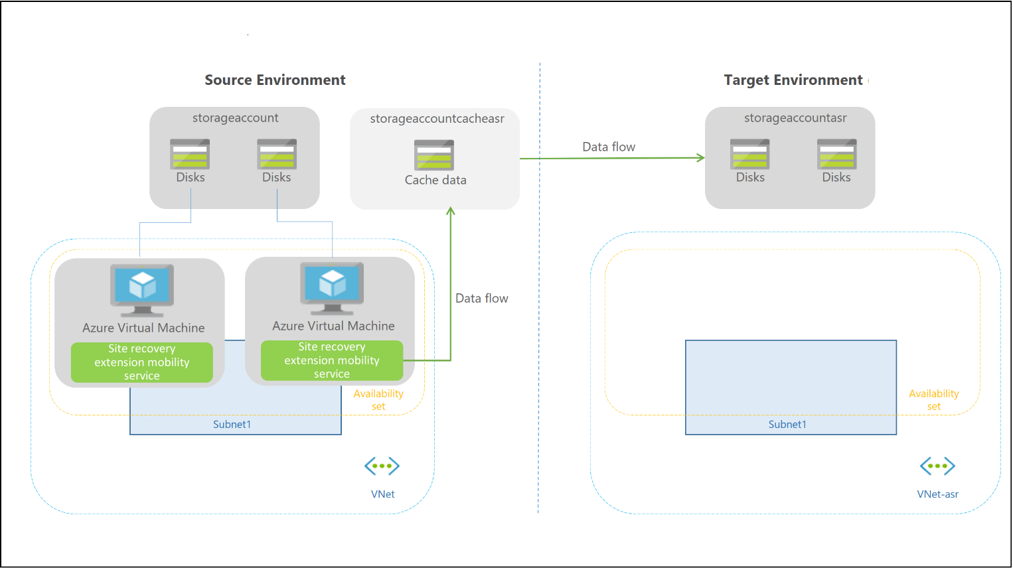

Failover process

When you initiate a failover, the VMs are created in the target resource group, target virtual network, target subnet, and in the target availability set. During a failover, you can use any recovery point that fall within the configured retention period.
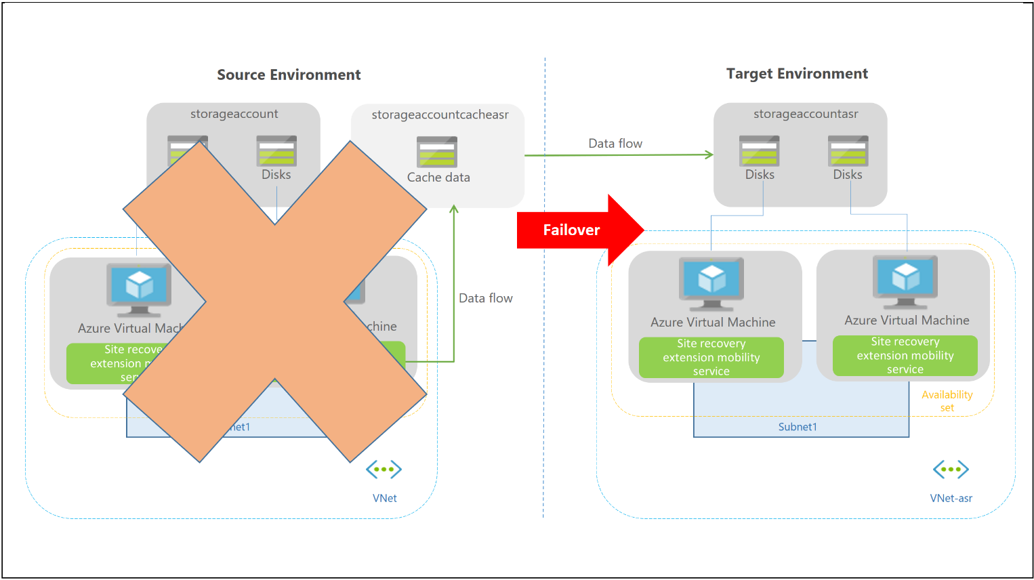

Roles and Responsibilities

Roles | Definition | Responsibilities
10M Managed Services DR Coordinator / Technical Account Manager | Person(s) responsible for the 10M DR policies and procedures and facilitating recovery and procedures for testing and recovery events | - Coordinate the teams and activities required to conduct IT Service Continuity  - Develop and maintain procedures for management during times of crisis  - Coordination of Service Continuity Tests, review and communicate the results of the tests  - To Communicate roles, responsibilities, procedures contained within the IT Service Continuity Plan to all staff and teams required in the plan  - Liaise with Client's DR coordinator to establish and maintain the crisis management process
10M Azure Managed Services Teams | Team that is responsible for implementing DR systems and ongoing monitoring and operations | - Planning and Architecture  - Installation of Azure Site Recovery  - Configuration of Replication  - Failover Testing and Results  - Monitoring of Azure Site Recovery of replication and health  - Yearly testing of DR Solution  - Recovery of Infrastructure in Azure  - Incident management and escalation
ELC application and database Teams | This is one or more teams responsible for and maintaining the technology used at the recovery site | - Provisioning and maintenance of the source application platforms (Applications)  - Provisioning and management of source database systems  - To execute the return to normal procedures
ELC app owners and QA testers,  DR Coordinator / Service Manager | Provide assistance from the customer’s site with data Verification and functional testing | - Develop and maintain procedures for management during times of crisis  - Coordination of Service Continuity Tests, review and communicate the results of the tests  - To do a handover to end users for functional testing  - To sign and approve pre and post tests
ELC Business Continuity Coordinator | Examine, evaluate and report on the adequacy of internal control | - To provide test assurance  - To improve the effectiveness of risk management, controls, and governance processes.  - To ensure alignment between IT DR and business continuity plans (ELC)  - To ensure compliance with relevant policies, procedures, and standards  - To perform an objective assessment of the effectiveness of risk management and whether the test meets the requirements of the Transnet minimum control framework
10M Service Desk | Notification of incident or change request | - To log changes, incidents, and request  - To updates changes, incidents, and request  - To close changes, incidents, and requests.

Declaring a Disaster

DR Process

This Disaster Recovery (DR) process includes:

- Invocation process
- Bridge call process
- Collaboration process
- War room process
- Communications Process
- Close out of the DR
- PIR (Post Incident Report) after the DR

Invocation Process (in the case of a Live DR)

In the event of a DR event, a high priority (P1) incident would be raised for the failed application or technology by ELC. ELC will determine the qualifying criteria for raising a P1 incident and initiating a failover for the workload.

Critical Incident Management Process

ELC would invoke their Critical Incident Management Process. The Critical Incident Management Team will be responsible for the following activities.

- P1 incident is already logged and tracked
- Ensure that the P1 communication templates are used
- Ensure that the DR invocation approval is received
- Escalate to 10th Magnitude to execute Failover Process
- Communicate bridge call as well as online meeting details to all stakeholders
- Attendance register is kept up to date during the DR
- Activity tracker is live and updated on the online meeting during the DR
- Milestone updates are regularly done during the DR
- Ensure that they communicate the DR resolution with the proper templates to all stakeholders once the DR is closed
- Ensure that the activity tracker as well as the Post Incident Report (PIR) is sent to the Service Manager within 7 days

Failover Process

10M will failover impacted servers from the source region to the destination region in Azure due to an unplanned event (natural or IT disaster) resulting in an unrecoverable or extended outage. Full Failover steps are documented below.

Close out of the DR

- The Service Manager will get all evidence as well as the vendor DR report within 7 days of the DR closure
- The Service Manager will get the PIR from the Critical Incident Management Team within 7 days of the DR closure and safe this centrally on the portal
- The Performance Manager Business Continuity will ensure that the DR process is measured against the DRP and make the necessary changes or adjustments accordingly
- The supporting vendor will provide an Incident PIR to the Service Owner
- The Service Owner needs to ensure that a documented Service Improvement Plan is generated based on the Incident and PIR.

Post Incident Report after the DR

- Once the DR is closed out the Critical Incident Management team will do the PIR within 7 days of the DR Closure and submit this to the Service Manager
- The Service Manager and Performance Manager Business Continuity will then analyse the PIR to see where we can make some improvements and what actions need to be implemented to mitigate the incident in the future

Site Information

Azure Information

Azure Subscription | Subscription ID | Resource Group
ELC-AM-PROD-PAAS | f57996ce-6cfe-400a-a311-f797fd8484d8 | RG-AM-EASTUS-PROD-CPM

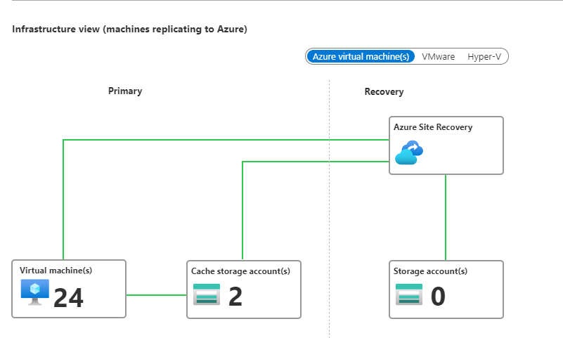

Protected Virtual Machine Information

Server Name |  |  | Region
US-NWK-EPMP01 |  |  | East Us
US-NWK-EPMP02 |  |  | East US
US-NWK-EPMP03 |  |  | East US
US-NWK-EPMP04 |  |  | East US
US-NWK-EPMP05 |  |  | East US
US-NWK-EPMP06 |  |  | East US
US-NWK-EPMP07 |  |  | East US
US-NWK-EPMP08 |  |  | East US
US-NWK-EPMP09 |  |  | East US
US-NWK-EPMP10 |  |  | East US
US-NWK-EPMP11 |  |  | East US
US-NWK-EPMP12 |  |  | East US

Disaster Recovery Plan

Failover

Perquisites:

- Access to the Azure Portal and the subscription that will be used for replication
- An Azure Virtual Network (vNet) and Subnet that will be used to provide network access to servers after failover. This vNet must be in the same region as the Recovery Service Vault
- A completed replication for a server stored in the Recovery Services Vault

Accessing the Recovery Services Vault

- Sign into the Azure Portal at https://portal.azure.com
- Click More Services, type “recovery” and select Recovery Services vaults
- Search for the Recovery Services Vault RSV-AM-WestUS-DR-CPM and verify that the servers you want to cut over has a green OK health and a status of Protected by navigating to Replicated Items under Protected Items on the left pane.

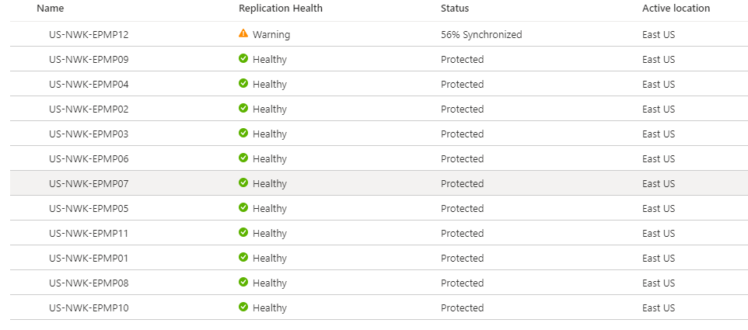
- Click on Overview (1.), Site Recovery (2.), and select Recovery Plan (3.)
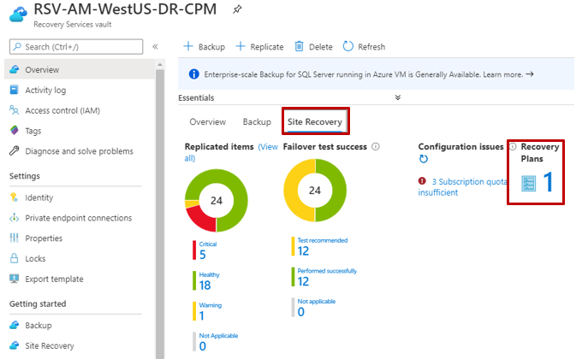
- Find and click on Recovery Plan CPM-DR-WestUS
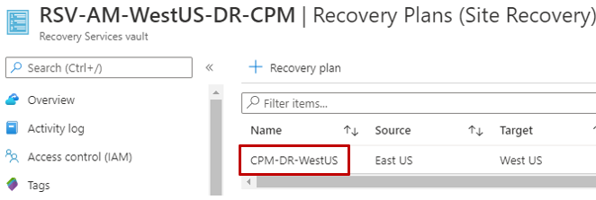

- Execute Recovery Plan
  - Click Failover
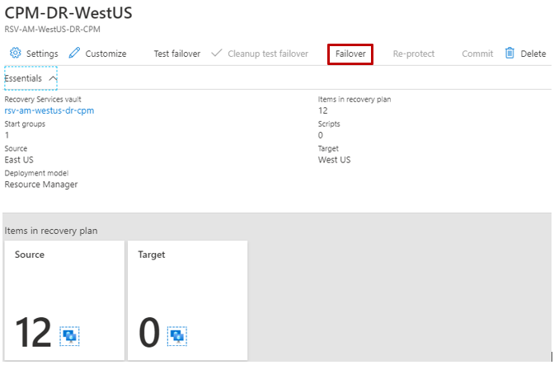
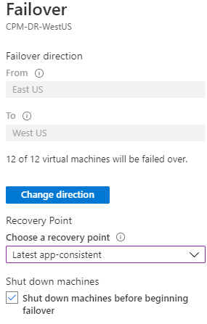
  - Select “Latest App-consistent” for the recovery point.
  - Click “OK” to begin the failover process.

- Monitor Recovery Plan Execution
  - Navigate to Site Recovery Jobs under Monitoring in the left pane
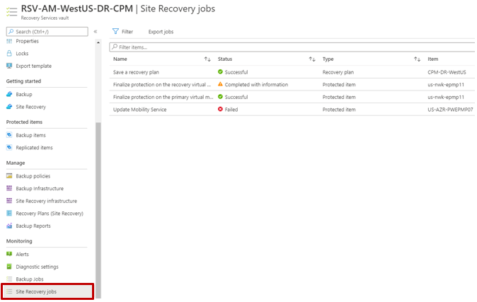
- Verify Azure Virtual Machine creation and health.
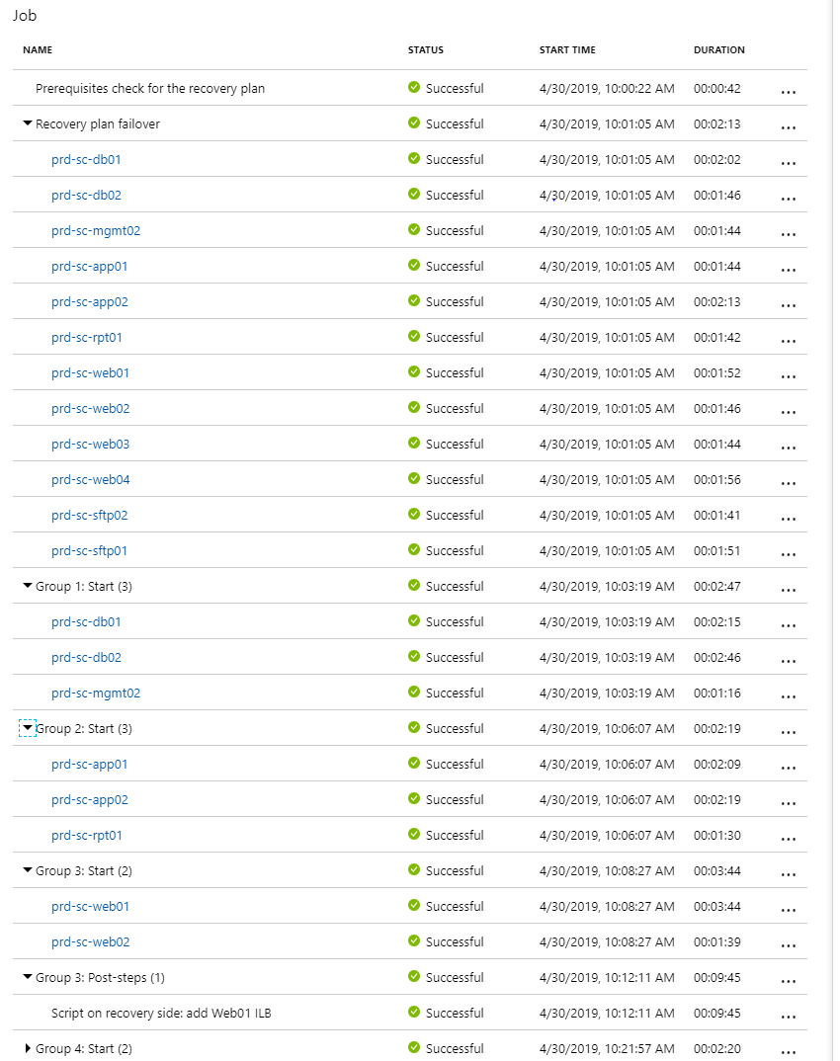

VM Blade

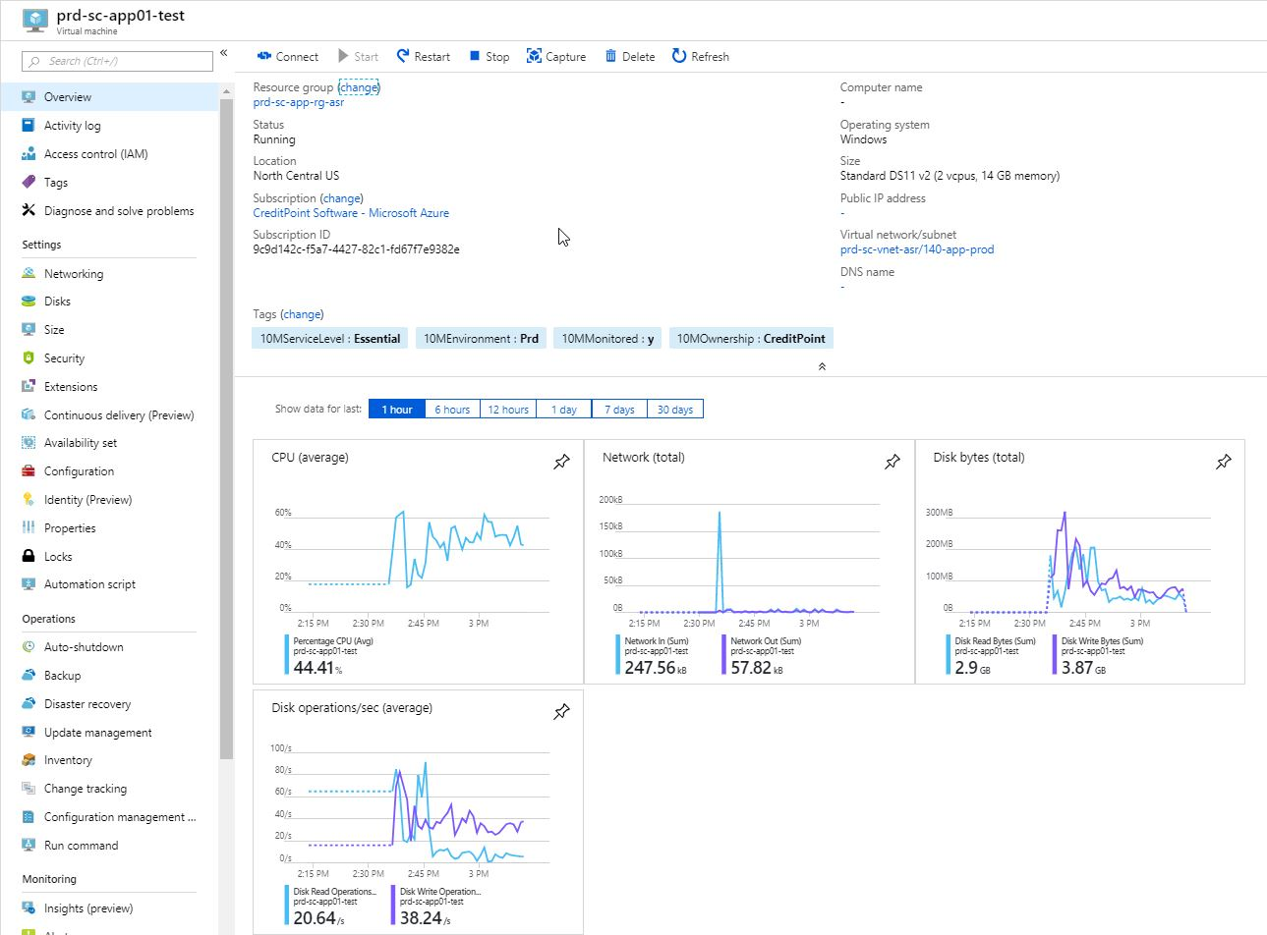
Boot Diagnostics
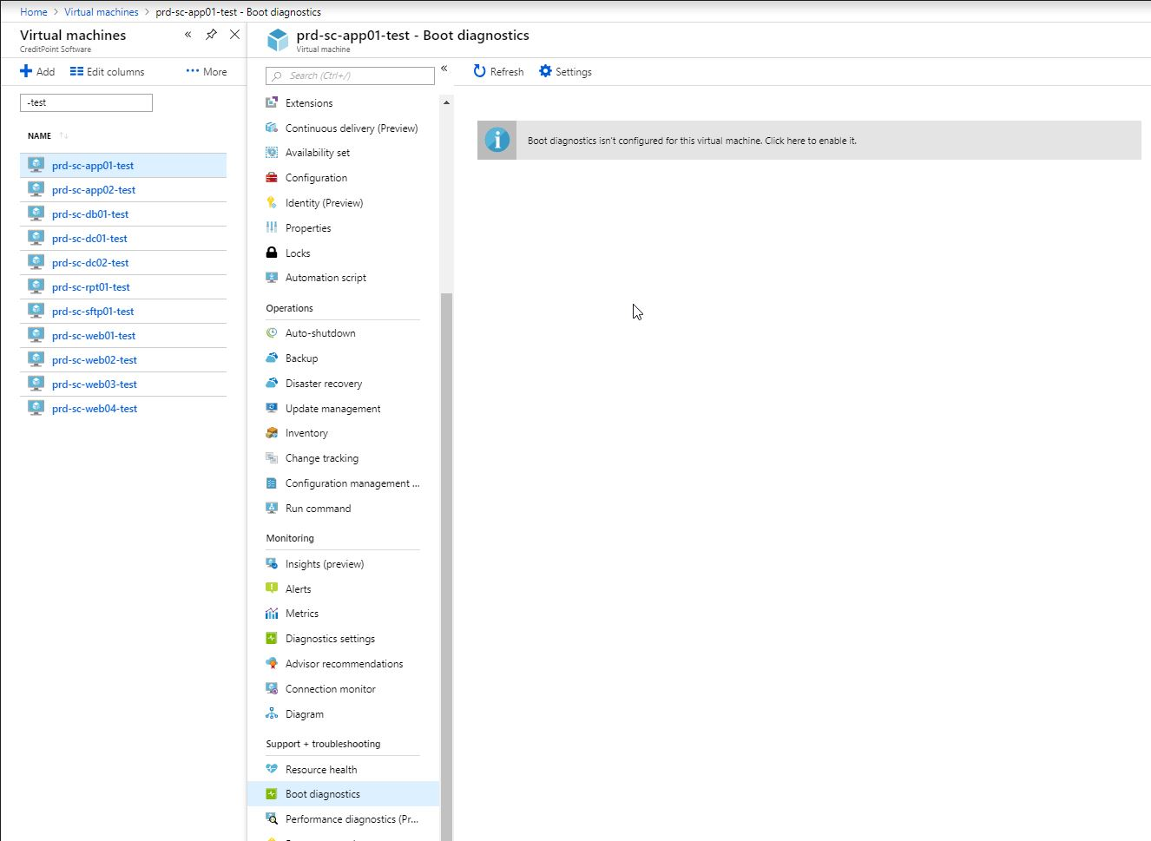
Boot Diagnostics Need a Storage Account in the VM’s region.

- Verify Connectivity
  - RDP into machines

Business Testing Handoff

<insert documentation>

Disaster Recovery Test Plans

Testing Types
Testing type vary from minimum preparation and resources to the most complex. Each bears its own characteristics, objectives, and benefits. The type of testing employed by an organization should be determined by, among other things, its age, and experience with disaster recovery planning, size, complexity, and nature of its business. Examples of testing methods in order of increasing complexity include:

Type of Test | Process | Frequency
Plan Review | This type of test requires copies of the plan to be distributed to different departments/functional areas for review. | Yearly (10M & ELC)
Tabletop exercise | This type of test requires representatives from each department/functional area come together to go over the plan to ensure its accuracy. The team reviews the plan, its scope, assumptions, and reporting structures. | Yearly (10M & ELC)
Test Failover | Operational and support functions come together to execute a test failover in Azure. | Yearly (10M)
Full-interruption Test | The original site is totally shut down (manually), a Test Failover is performed, and application testing and processing tests takes place at the DR site. Upon completion of the test the original site infrastructure is restored. | As Required (10M & ELC)

Plan Review

For this test the ELC, DR Coordinator will distribute the DraaS Playbook for review. The ELC DR coordinator is responsible for generating a Service Improvement Plan based on the output of this test.

Tabletop exercise

For this test the ELC, DR Coordinator will coordinate a meeting for review of the plan. The ELC DR coordinator is responsible for generating a Service Improvement Plan based on the output of this test.

Test Failover

For this test the 10M Managed Services DR Coordinator / Technical Account Manager is responsible for generating a Service Improvement Plan based on the output of this test.

Full-interruption Test

For this test the ELC DR Coordinator in conjunction with the 10M Managed Services DR Coordinator will coordinate a meeting for review of the plan. The ELC DR coordinator is responsible for generating a Service Improvement Plan based on the output of this test.

Appendix

Abbreviations

Abbreviation | Description
DR | Disaster Recovery
RTO | Recovery time objective
RPO | Recovery point objective
SLA | Service Level Agreement
BCM | Business continuity management
BCP | Business continuity plan
BIA | Business impact analysis

Definitions

Term | Description
Alternate site | Alternate operating location selected to be used by an organization when normal business operations cannot be carried out using the normal location after a disruption has occurred
Business continuity management | Holistic management process that identifies potential threats to an organization and the impacts to business operations whose threats, if realized, might cause, and which provides a framework for building organizational resilience with the capability for an effective response that safeguards the interests of its key stakeholders, reputation, brand and value-creating activities
Business continuity plan | Documented procedures that guide organizations to respond, recover, resume, and restore to a pre-defined level of operation following disruption NOTE Typically this covers resources, services and activities required to ensure the continuity of critical business functions.
Business impact analysis | Process of analyzing operational functions and the effect that a disruption might have upon them
Critical | Qualitative description used to emphasize the importance of a resource, process or function that must be available and operational constantly or available and operational at the earliest possible time after an incident, emergency or disaster has occurred
Disruption | Incident, whether anticipated (e.g. hurricane) or unanticipated (e.g. power failure/outage, earthquake, or attack on ICT systems/infrastructure) which disrupts the normal course of operations at an organization location
Disaster recovery | Ability of an organization to support its critical business functions to an acceptable level within a predetermined period of time following a disruption
Disaster recovery plan | Clearly defined and documented plan which recovers capabilities when a disruption occurs
Recovery point objective RPO | Point in time to which data must be recovered after a disruption has occurred
Recovery time objective RTO | Period within which minimum levels of services and/or products and the supporting systems, applications, or functions must be recovered after a disruption has occurred resilience ability of an organization to resist being affected by disruptions
Trigger | Event that causes the system to initiate a response  NOTE: Also known as triggering event.

